STATA assignment
2.
Jackson, Gangnon, Evans, et al (American Journal of Respiratory and Critical Care
Medicine 2008, 178: 667 - 672) provided the proportion of children experiencing asthma
by six years of age with respect to whether they had been previously exposed to
the human rhinovirus (HRV) in the first year of their life. The results of this study are
described in a 2 x 2 contingency table as shown below:
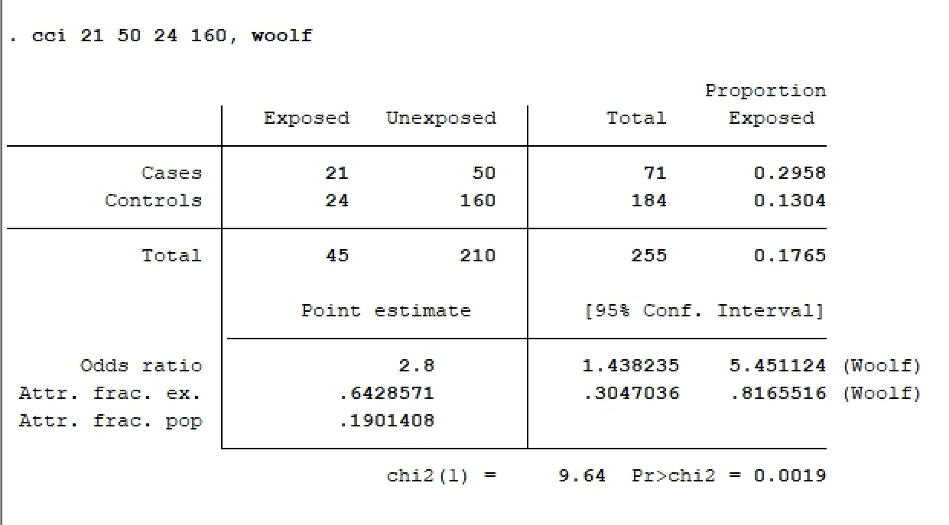
Interpretation: The OR estimate for the association between asthma and HRV
is 2.8 (95% CI 1.43 – 5.45, p = 0.0019).

3.
In the study by Jackson, Gangnon, Evans, et al (2008), to define the relationship between
exposure to HRV in early life and the development of childhood asthma, the 259 children
were followed prospectively from birth to six years of age.
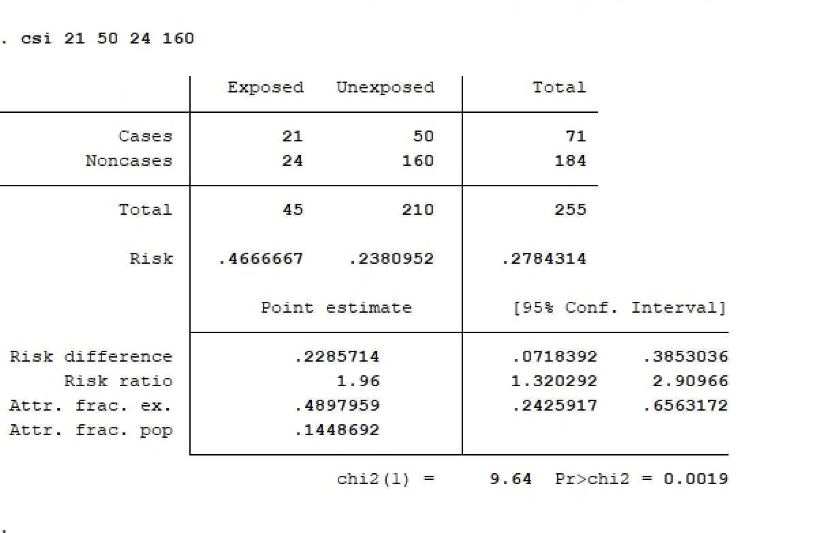
(a) The risk of developing asthma in children who have HRV is 0.4667.
The risk of developing asthma in children who don’t have HRV is 0.238
(b) The risk of asthma, among children with HRV, is 1.96 times that of those without HRV
(95% CI 1.32– 2.90, p = 0.0019).
(c) Because this is a prospective cohort study, the risk ratio is the more appropriate effect measure. RR is directly interpretable as a ratio of risks and is the natural measure for cohort studies.
(d) OR=2.8, RR=1.96.
(2.80 − 1.96)/1.96 = about 43% relative. However, the outcome is not rare (here 47% in exposed, 24% in unexposed). For common outcomes, the OR departs from and is larger than the RR; for rare outcomes OR is similar to the RR.

